Functional Specification
Version [1.0.0]

Implementasi Vision
(Interface Vision – GL & AP)

Prepared By
RUMANTININGTYAS
PT. KALBE BLACKMORES NUTRITIONALS

Date
[30/11/2020]
Revision history
Version | Date |  | Author(s) | Description
1.0.0 | 30 Nov 2020 |  | Rumantininggtyas | No Previous Document
Document Approval
Full name |  | Job Title |  |  | Signature | Signature Date

User Interface Vision – Oracle Payable

Flow
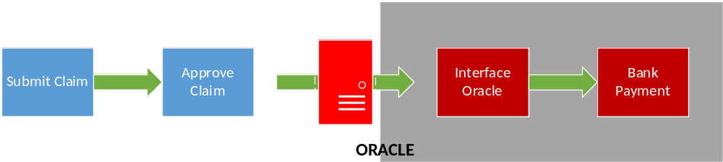

Interface Between Vision – Oracle Payable AP_INVOICE_INTERFACE

Insert Data Ke AP_INVOICE_INTERFACE
Field Name | Description | Mandatory | Data Type | Notes
INVOICE_ID | Kode unik transaksi | Y | Number | Populated from AP_INVOICES_INTERFACE_S.NEXTVAL
INVOICE_NUM | No document Claim yang di Vision | Y | Varchar | Nomor document harus unik, untuk satu vendor_id
INVOICE_TYPE_LOOKUP_CODE | Tipe Invocie Transaksi. | Y | Varchar | Default ‘STANDARD’.
INVOICE_DATE | Tanggal Claim | Y | Date
VENDOR_ID | Vendor Id atas vendor date | Y | Varchar | Active vendor. Validasi PO_VENDORS
VENDOR_SITE_ID | Vendor Site Id atas vendor terkait | Y | Varchar | Active pay site. Validasi PO_VENDOR_SITES
INVOICE_AMOUNT | Nilai transaksi | Y | Number | Nilai harus Positif
INVOICE_CURRENCY_CODE | Matauang transaksi | Y | Varchar | Default IDR
TERMS_NAME | Termin pembayaran | Y | Varchar | KBN 14 DAYS AFTER RECEIVED COMPLETE INVOICE
DESCRIPTION | Keterangan transaksi | Y | Varchar | Description pada line claim
CREATION_DATE | Tanggal entry transaksi | Y | Date
SOURCE | Source Aplikasi | Y | Varchar | Default VISION
GROUP_ID | Batch Name | Y | Varchar | Format RFP-NAMA USER-CABANG-TANGGAL-(TANGGAL APPROVE)  FPR-TYAS-JKT-040121-12345678901234567890123456789
GL_DATE | Tanggal pencatatan GL | Y | Varchar | Validasi tanggal GL dalam periode OPEN  Tanggal final approve claim
ORG_ID | Operating Unit | Y | Varchar | Default 82
TERMS_DATE | Tanggal Jatuh Tempo (termin) | O | Varchar

Action Control
Jalankan Request Program : Request for Payment untuk push RFP di Oracle. Parameter menggunakan tanggal.

Interface Between Vision – Oracle Payable AP_INVOICE_LINES_INTERFACE

Insert Data Ke AP_INVOICE_LINES_INTERFACE
Field Name | Description | Mandatory | Data Type | Notes
INVOICE_ID | Kode unik transaksi (dari Oracle) | Y | Number | Populated from AP_INVOICES_INTERFACE_S.NEXTVAL
INVOICE_LINE_ID | Kode unik transaksi Line (dari Oracle) | Y | Number | Populated from AP_INVOICE_LINES_  INTERFACE_S.NEXTVAL
LINE_NUMBER | Line Number | Y | Number
LINE_TYPE_LOOKUP_CODE | Tipe line transaksi | Y | Number | Default “Item”
AMOUNT | Nilai transaksi per line | Y | Number | Ambil nilai DPP
ACCOUNTING_DATE | Tanggal pencatatan GL | Y | Date | Sama dengan GL_Date pada AP_INVOICES_INTEREFACE
DESCRIPTION | Deskripsi transaksi line | Y | Varchar | DESCRIPTION LINE CLAIM
DIST_CODE_CONCATENATED | COA | O | Varchar
DIST_CODE_COMBINATION_ID | ID COA | Y | Number | Validasi sesuai dengan GL_CODE_COMBINATIONS
CREATED_BY | id user name | Y | Number
CREATION_DATE | Tanggal creation | Y | Date | Default SYSDATE
ORG_ID | operating Unit | Y | Number | Default 82

Action Control
Jalankan Request Program : Request for Payment untuk push RFP di Oracle. Parameter menggunakan tanggal.

User Interface Vision – Oracle General Ledger

Flow
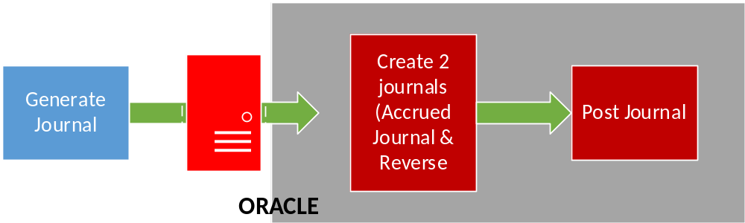

Interface Between VISION – Oracle Payable GL_INTERFACE

Insert Data Ke GL_INTERFACE
Field Name | Description | Mandatory | Data Type | Notes
Legder ID | Ledger ID | M | Char | Default 2021
ACCOUNTING_DATE | Tanggal transaksi, sesuai dengan GL date yang dipilih | M | Date
CURRENCY_CODE | Matauang transaksi | M | Char
ACTUAL_FLAG | Journal Actual | M | Char | Default A
USER_JE_CATEGORY_NAME | Kategori Journal | M | Char | Default KBN-Vision Accrual
USER_JE_SOURCE_NAME | Source transaksi | M | Char | KBN-Vision
CURRENCY_CONVERSION_DATE | jika mata uang selain IDR, maka field ini wajib diisi | O | Date
SEGMENT1 | COA Segment1 | M | Char
SEGMENT2 | COA Segment2 | M | Char
SEGMENT3 | COA Segment3 | M | Char
SEGMENT4 | COA Segment4 | M | Char
SEGMENT5 | COA Segment5 | M | Char
SEGMENT6 | COA Segment6 | M | Char
SEGMENT7 | COA Segment7 | M | Char
ENTERED_DR | Nilai transaksi Debit | M | Char
ENTERED_CR | Nilai Transaksi Credit | M | Char
REFERENCE1 | Batch Name | M | Char
REFERENCE4 | Journal Entry Name | O | Char
REFERENCE10 | Journal Line Description | M | Char
JE_BATCH_ID | Pupulated GL_INTERFACE_S.NEXTVAL | M | Char
JE_HEADER_ID | Pupulated GL_INTERFACE_S.NEXTVAL | M | Char
GROUP_ID | Unik ID, untuk membedakan setiap data yang push ke oracle | M | Char
ATTRIBUTE1-15 | Informasi Tambahan dari Vision | O | Char

Action Control
Jurnal yang terbentuk ada dua:
- Journal Accrual
- Journal balikn (reverse) atas journal 1

User Interface Vision – Oracle Payable (Suppliers)

Flow

Interface Between VISION – Oracle ap_suppliers_int

Field Name | Description | Mandatory | Data Type
Vendor Name | Nama Outlet | Y
Segment1 | Kode Supplier |  | Initial vendor name, jika ada yang sama tambahkan 1
Vendor_type_lookup_code | KBN_SUPPLIER
Allow AWT Flag | default Y
TCA_SYNC_VENDOR NAME | Nama sesuai NPWP | Y
TCA_SYNC_VAT_REG_NUM | Nomor NPWP
Vendor_Site_Code | Kode Supplier Site | Y | NNN-APO-TPA1,  TNN: Trade 3rd  NNN: Non Trade  TAF : Trade Affiliasi  TNN: Trande non Afiliat  Defulat APO  sesuai dengan field Segment 1
Purchasing Site_flah | default Y | Y
Pay_site_Flag | default Y | Y
Address_line1 | Alamat Outlete | Y
City | Kota sesuai alamat | O
Zip_Code | kode Post sesuai alamat | O
Country | negara sesuai dengan alamat | O
Phone | Nomor Telpon | O
Bank_Account_Name | Nama Pemilik Rekening | O
Bank Account Num | Nomo Rekening | O
Bank Name | Bank Name atas rekening tersebut | O
Vat_Code | Default PPN untuk di payable (NO_PPN atau PPN_10%) | O
VAT_Registration Num | Nomor NPWP | O
Attribute1 | Kode Cabang | Y
Attribute2 | Informasi Tambahan | N

Action Control
N/A

Appendix

